**NETWORK ANALYSIS for: AP Calculus BC**

|  |
| --- |
| **LLP ANALYSIS, PART 1: OVERALL PROFICIENCY PERFORMANCE** |

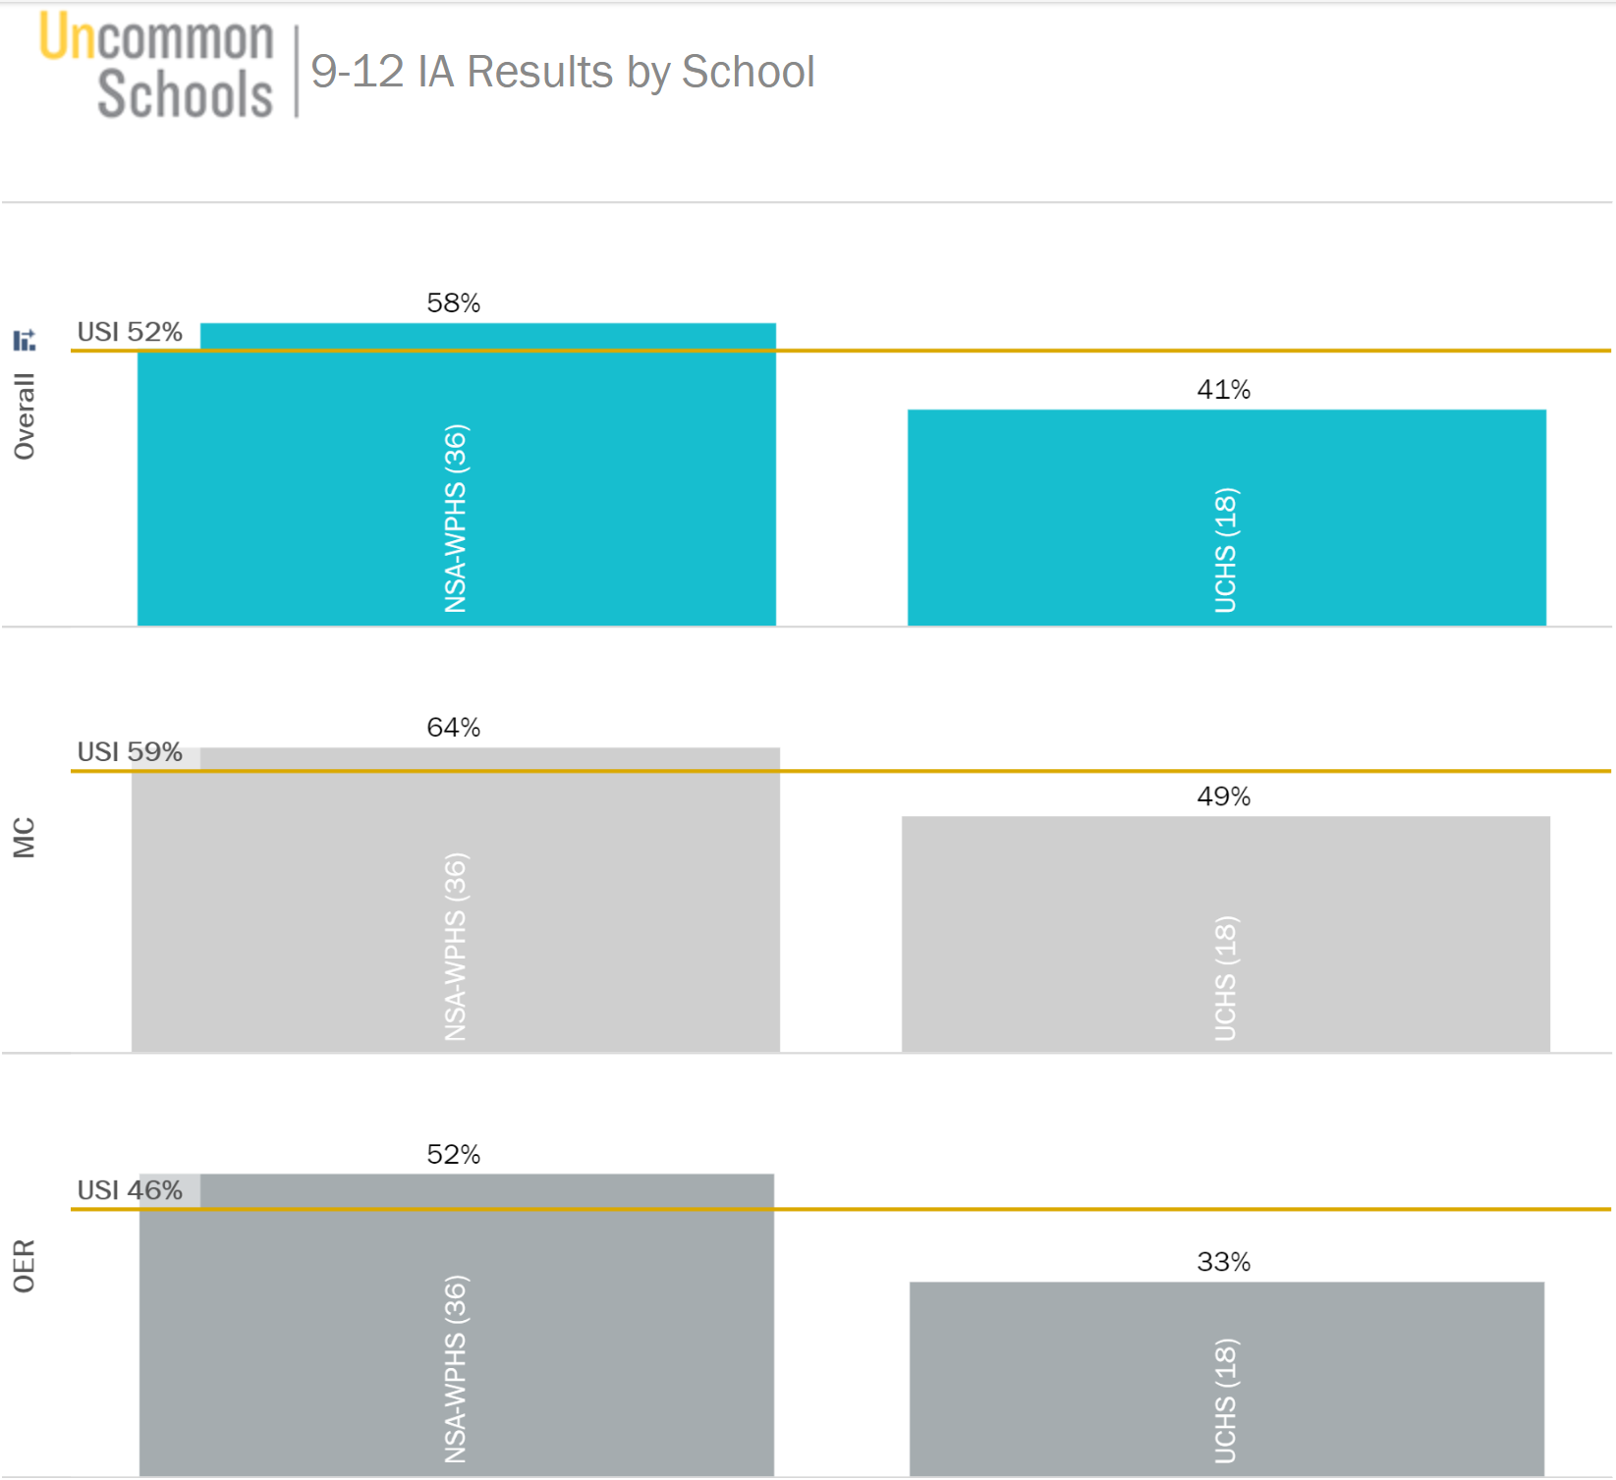

|  |
| --- |
| **LLP ANALYSIS, PART 2: STANDARDS PROFICIENCY DEEP DIVE** |

*On Tableau, click on the “9-12 IA Results by Standard” to identify the 1-2 lowest performing standards. (Teachers will choose 1 additional gap to close with their students). Use the “Response Frequency by Standard” Report on Illuminate to complete a more thorough analysis of question-specific data and wrong answer choices. Reference scanned student work samples as well to determine the conceptual misunderstandings at the root of these gaps.*

| **Key Errors** | **Standard** | | **Related Questions** | **Conceptual Fixes** |
| --- | --- | --- | --- | --- |
| **Highest leverage errors and conceptual misunderstandings to fix** | **AP Calc**  **Learning Objective** | **USI Calc Standard** | **IA Questions/ Tasks** | **What key conceptual understandings will fix these gaps?** |
| 10, Specific vocabulary of speed decreasing  17, Not breaking down the prompt in the question, need to annotate *at rest.*  85, The gap appears to be knowing how to start the problem, those who started solved the problem correctly  2C, 2 point question, students are starting the write process but not articulating the reason for the answer.  2D, Similar to 2C, it appears students are getting the right answer but not articulating it correctly  4B, Starting with incorrect equation () or not able to break down the problem.  5D, Recognizing that the problem is related rates, but computational errors due to complexity of substitutions | Derivatives.3C.Applications | 05.RelatedRates;  05.ParticleMotion | 10 (80%)  17 (41%)  85 (50%)  2C (59%)  2D (59%)  4B (26%)  5D (47%) | MPAC 1: Reasoning with Theorems and Definitions   * When breaking down a question, it is helpful to reference the definition of a term. These annotations will inform my first step to solving the question & allow me to accurately justify my response.   *~~Hypothesis: The derivative is a tool that allows me to find the rate of change of one variable with respect to another. For example, the rate of change of position with respect to is . This tells me how the position is changing with respect to time.~~* |
| 12, Students are confusing the following relationship:   * concave down * decreasing * negative   22, some students are making sign charts, do not have the right process for absolute maximum, prior Calc A knowledge.  83, students are accounting for the upper limit by substituting, BUT they are not multiplying by the derivative of the upper  limit.  3B, Students show the FTC connection in the part A, however, knowing how to connect this to the vocab of Point of Inflection was the gap, this then prevents earning the explanation point.  3C, Concavity emerges here again and how it is connected to the graph.  3D, Missing understanding of absolute maximum  6B, Point of Inflection arises again and errors start with a lack of annotation to inform procedure. | Integrals.3A.Function;  Derivatives.2A.GraphicAnalysis | 06.Fundamental Theorem of Calculus  04.Graphic Analysis | 12 (44%)  22 (19%)  83 (20%)  3B (46%)  3C (53%)  3D (5%)  6B (40%) | The concavity of a functions corresponds to how the derivative is changing as -increases   * If is concave up, is increasing. * If is concave down, is decreasing.   This is helpful graphically when using to analyze Algebraically, this is not very helpful. However, if is increasing, then its derivative, must be positive. Thus, it follows that:   * If is concave up, is positive. * If is concave down, is negative.   *~~Original Hypothesis: FTC: The derivative of the accumulation function is the rate of change of the area with respect to the limits of the integrand. By the FTC, if the upper limit is , the derivative it equivalent to the integrand.~~*  *~~If , then~~* |

|  |
| --- |
| **LLP ANALYSIS, PART 3: RETEACH PLANNING** |

|  |  |  |  |
| --- | --- | --- | --- |
| **Reteach Plan: Week 12 Float #1** | | | |
| **Student Exemplar** | | | |
| *Embed or screenshot the top student exemplar from our network that highlights success on this standard/task* | | *Explain/label the attributes of the work sample that make it exemplary*  Analia has read the prompt and translated the *at rest* portion by writing the **highlighted .**  We can then see that her first step is to find by taking the derivative of the given . She can then reference this same definition and set here derivative equal to zero.  Analia uses her algebra skills to solve for the value of that will satisfy her original annotation . | |
| **Highest Leverage Conceptual Gaps to Fix:** | | | |
| There are two layers to closing these types of gaps:   * First, students need to understand why an annotation like Analia’s makes sense (i.e. if a particle is at rest, it is not moving. Therefore it’s position is not changing and it’s velocity, rate of change of position, must be zero) * Secondly, students need to apply this knowledge in context by annotating the prompt and then connecting it to inform their process. | | | |
| **How will the priority conceptual gap(s) be addressed in a reteach lesson next week?** | | | |
| **Broad Overview of the Reteach:** *Articulate the general plan for this reteach, including which reteach technique(s) will be utilized (modeling, discourse, monitoring laps, etc.). If applicable, name which IA items and work samples may be used to guide Show Call/discourse.* | | | |
| Focus of Reteach: Particle motion definitions   * Provide table of common terms used in particle motion questions in column 1. In partners, student write the ideal SMART annotation in column 2 and a reason/picture that supports it in column 3. * Students independently use the table to solve 3 multiple choice questions, TT, Whole Class Review * Students retry #17 to make an exemplar response using this practice. * Additional at bats in particle motion. | | | |
| **Aggressive Monitoring Laps:** *For this re-teach lesson, outline**the AggMo laps that one will narrate, the coding or cues for student feedback, and notes on leading discourse* | | | |
| **Laps** | **Coding/Cues** | | **Discourse** |
| 1. I am looking for your annotation. 2. Accurate first step based off your annotation 3. Final solution | R = Reread/break down the prompt  C = Computational Error | | * Why does this SMART annotation make sense? * How does this SMART annotation allow XX to start solving the problem? |

|  |  |  |  |
| --- | --- | --- | --- |
| **Reteach Plan: Week 13 Float #1** | | | |
| **Student Exemplar** | | | |
| *Embed or screenshot the top student exemplar from our network that highlights success on this standard/task* | | *Explain/label the attributes of the work sample that make it exemplary*  Serena uses her definition of point of inflection to recall that it signifies a change in concavity.  She then goes two steps further in writing down the other connections she remembers for a change in concavity.  Finally, recognizing that this is an algebraic question, she finds the second derivative and sets it equal to solve for 0 and the x-coordinate of the point of inflection. | |
| **Highest Leverage Conceptual Gaps to Fix:** | | | |
| The skills to practice in this reteach build off the practice that is emphasized in the first reteach. Students need to see the connection between concavity and and so that they are not just memorizing these annotations, but they can unpack their understanding in the moment as we see Serena do here on here Free-Response Question  Note: Students may have learned a very simplified version of concavity earlier in their math careers as *holding/not holding water* or *smiley face/frowny face*. While this serves its purpose, it is not a rigorous definition and can be a hindrance in applications to calculus unless it is explicitly unlearned. | | | |
| **How will the priority conceptual gap(s) be addressed in a reteach lesson next week?** | | | |
| **Broad Overview of the Reteach:** *Articulate the general plan for this reteach, including which reteach technique(s) will be utilized (modeling, discourse, monitoring laps, etc.). If applicable, name which IA items and work samples may be used to guide Show Call/discourse.* | | | |
| * Task A to compare the graph of , , and to get to the key idea, follow with discourse to name the following.   + concavity 🡪 increasing/decreasing 🡪 positive/negative * Task B to provide an algebraic and graphical example to make SMART annotations to solve with key idea.   + Name the advantage and relevance of inc/dec and positive/negative to informing process. * Additional at bats | | | |
| **Aggressive Monitoring Laps:** *For this re-teach lesson, outline**the AggMo laps that one will narrate, the coding or cues for student feedback, and notes on leading discourse* | | | |
| **Laps** | **Coding/Cues** | | **Discourse** |
| 1. I am looking for your annotation. 2. Accurate first step based off your annotation 3. Final solution | R = Reread/break down the prompt  C = Computational Error | | * Why does this SMART annotation make sense? * If I draw a concave up curve, how do I see that this annotation makes sense? * How does this SMART annotation allow XX to start solving the problem? |

|  |
| --- |
| **TEACHER ANALYSIS, PART 1: RESULTS OVERVIEW** |

|  |  |  |  |  |
| --- | --- | --- | --- | --- |
| **17-18 IA #1** | | | | |
| **Section/Period** | **MC%** | **OR%** | **Combined %** | **% above/below network avg.** |
|  |  |  |  |  |
|  |  |  |  |  |
|  |  |  |  |  |
|  |  |  |  |  |
| **Total For All Sections** |  |  |  |  |

**CELEBRATING SUCCESSES/BRIGHT SPOTS**

|  |
| --- |
| **Course-Wide** |
|  |
| **Individual Sections** |
|  |
| **Individual Questions/Standards** |
|  |

|  |
| --- |
| **TEACHER ANALYSIS, PART 2: CAMPUS-SPECIFIC RETEACH NEEDS** |

**Analyzing Your Own Students’ Work:** *Reference the LLP analysis above when you do your own student work analysis.*

|  |
| --- |
| **Campus Analysis** |
| **Unpack the Network Exemplar** |
| *What were the keys to an ideal answer? So the exemplar needs to include…*  *How does this [part of the exemplar] align with the standard?* |
| **Your Student Exemplar** |
| *How does your student exemplar compare to the network exemplar? What is the gap?*  *Does your student exemplar offer something that your exemplar does not?* |
| **Student Work Analysis** |
| *Starting with the medium work, then moving to the low work:*  *What are the gaps that we see between the mediums and our student exemplar?*  *What are the highest leverage misconceptions to fix that will move them most quickly?*  *What do we see students doing that led to this error?* |
| **Name the Error and Conceptual Understanding** |
| *Describe the student error and name the conceptual misunderstanding evident in that error* |
| **Identifying Reteach Needs** |
| *After reviewing the LLP reteach plan above, what additional reteach steps must you take to close your student-specific gaps? Articulate the general plan for this reteach, including which reteach technique(s) will be utilized (modeling, discourse, monitoring laps, etc.).* ***Script below:*** |
|  |

Using the Performance Summary report in Illuminate, **identify 1 additional** standard where your students struggled the most:

|  |  |  |
| --- | --- | --- |
| **Standard &**  **Percent Mastery** | **Question Numbers** | **What key conceptual misunderstandings were revealed in student work?**  **What conceptual understandings would fix the error(s)?** |
|  |  |  |
| **What are the key reteach steps based on the analysis?** |
|  |

|  |
| --- |
| **TEACHER ANALYSIS, PART 3: ACADEMIC HABITS REVIEW** |

*Look through your students’ test booklets to determine the state of their academic habits. Tally the number of students in each class who showed proficiency with specific grade-level academic habits for your content area.*

|  |  |  |  |  |
| --- | --- | --- | --- | --- |
| **17-18 IA #1** | | | | |
| **Section/Period** | **Proficient with Stamina/Test Completion** | **Proficient with Content Habit #1: Annotation of Texts, Problems** | **Proficient with Content Habit #2: Evidence of Multiple Choice Reasoning** | **Proficient with Content Habit #3: Open-Ended Responses or Teacher choice** |
|  |  |  |  |  |
|  |  |  |  |  |
|  |  |  |  |  |
|  |  |  |  |  |
| **Average For All Sections** |  |  |  |  |

|  |
| --- |
| **TEACHER ANALYSIS, PART 4: INTERVENTION PLAN FOR SPECIFIC STUDENTS** |

*Utilizing the Matrix Report, identify your lowest 5-10 students across the classes you teach. Look at their work in their test booklets. Find trends in individual student performance.*

|  | **Student Name** | **MC Average** | **OER**  **Average** | **Key Standards Missed** | **Key Reteaching Actions** |
| --- | --- | --- | --- | --- | --- |
| 1 |  |  |  |  |  |
| 2 |  |  |  |  |  |
| 3 |  |  |  |  |  |
| 4 |  |  |  |  |  |
| 5 |  |  |  |  |  |
| 6 |  |  |  |  |  |
| 7 |  |  |  |  |  |

|  |
| --- |
| **TEACHER ANALYSIS, PART 5: SIX WEEK ACTION PLAN – RTD/FLOAT LPs and AGGMO NEEDS** |

|  |  |  |  |  |  |  |
| --- | --- | --- | --- | --- | --- | --- |
|  | **Week of:_____** | **Week of:_____** | **Week of:_____** | **Week of:_____** | **Week of:_____** | **Week of:_____** |
| **Response-to-Data/Float Lesson Topics** |  |  |  |  |  |  |
| **Aggressive Monitoring Focus** | Whole Class:  Specific Students: | Whole Class:  Specific Students: | Whole Class:  Specific Students: | Whole Class:  Specific Students: | Whole Class:  Specific Students: | Whole Class:  Specific Students: |

**Appendix I: Prioritizing Network Standard Focus & Suggested Responses**

|  |  |  |  |  |  |  |  |  |  |  |
| --- | --- | --- | --- | --- | --- | --- | --- | --- | --- | --- |
|  | USI | WPHS | UCHS | Delta | Q | Correct | Gap | Y/N | Notes: | Suggested Response |
| UHAI.APCalc.Derivatives.2A.GraphicAnalysis | 55% | 59% | 47% | 12% | 11 | 6.05 | 5 | Y | High freq, <60% | Network Reteach |
| UHAI.APCalc.Derivatives.3B.TangentLines | 42% | 48% | 32% | 16% | 6 | 2.52 | 3 | Y | High freq, <60% | Network Reteach |
| UHAI.APCalc.Derivatives.3C.Applications | 46% | 53% | 33% | 20% | 8 | 3.68 | 4 | Y | High freq, <60% | Network Reteach |
| UHAI.APCalc.Integrals.3A.Function | 36% | 42% | 24% | 18% | 3 | 1.08 | 2 | Y | High freq, <60% | Network Reteach |
| UHAI.APCalc.Integrals.4A.Interpret | 89% | 94% | 78% | 16% | 1 | 0.89 | 0 | N | >60%, Covered deeper in Q2 | Q2 Content |
| UHAI.APCalc.Integrals.4B.AverageValue | 17% | 19% | 12% | 7% | 2 | 0.34 | 2 | N | Covered deeper in Q2 | Q2 Content |
| UHAI.APCalc.Integrals.4E.Apps | 13% | 19% | 0% | 19% | 1 | 0.13 | 1 | N | Covered deeper in Q2 | Q2 Content |
| UHAI.APCalc.Derivatives.1B.Approximate | 32% | 40% | 17% | 23% | 1 | 0.32 | 1 | N | Low frequency, quick fix | Quick Hit |
| UHAI.APCalc.Derivatives.3A.Interpret | 46% | 46% | 45% | 1% | 2 | 0.92 | 1 | N | Low freq, quick hit | Quick Hit |
| UHAI.APCalc.Derivatives.1C.Calculate | 66% | 73% | 52% | 21% | 8 | 5.28 | 3 | N | >60% | Spiral Practice |
| UHAI.APCalc.Integrals.3B.Calculate | 61% | 66% | 53% | 13% | 6 | 3.66 | 2 | N | Covered deeper in Q2 | Spiral Practice |
| UHAI.APCalc.Limits.1B.Estimate | 85% | 89% | 78% | 11% | 1 | 0.85 | 0 | N | >60% | Spiral Practice |
| UHAI.APCalc.Limits.1C.Determine | 52% | 61% | 33% | 28% | 1 | 0.52 | 0 | N | Low frequency | Spiral Practice |
| UHAI.APCalc.Limits.1D.Behavior | 87% | 94% | 72% | 22% | 2 | 1.74 | 0 | N | >60% | Spiral Practice |
| UHAI.APCalc.Derivatives.2B.Differentiability | 61% | 59% | 65% | 6% | 3 | 1.83 | 1 | N | Address class specific | Teacher Specific |
| UHAI.APCalc.Derivatives.4A.MVT | 39% | 44% | 28% | 16% | 1 | 0.39 | 1 | N | Low frequency | Teacher Specific |
| UHAI.APCalc.Integrals.2B.Approximate | 57% | 63% | 45% | 18% | 6 | 3.42 | 3 | N | Easy win, high frequency | Teacher Specific |
| UHAI.APCalc.Integrals.2C.AreaProperties | 57% | 72% | 28% | 44% | 2 | 1.14 | 1 | N | Big difference in data | Teacher Specific |
| UHAI.APCalc.Limits.2A.Continuity | 75% | 85% | 53% | 32% | 2 | 1.5 | 1 | N | >60% | Teacher Specific |
| UHAI.APCalc.Integrals.2A.LimDef | 20% | 22% | 17% | 5% | 1 | 0.2 | 1 | N | Low frequency | Teacher Specific  (with Derivatives.1A.LimDef) |
| UHAI.APCalc.Derivatives.1A.LimDef | 65% | 70% | 56% | 14% | 2 | 1.3 | 1 | N | Low frequency, >60% | Teacher Specific  (with Integrals.1A.LimDef) |

**Appendix II: Narrowing focus on Priority Standards based off question analysis.**

|  |  |  |  |  |  |  |
| --- | --- | --- | --- | --- | --- | --- |
| Q | AP Calc Learning Objectives | USI Calc Standards by Unit | USI | WPHS | UCHS | Delta |
| 3C | UHAI.HS.APCalc.Derivatives.2A.GraphicAnalysis | UHAI.HS.Calc.04.GAIncDec | 53% | 58% | 42% | 16% |
| 3B | UHAI.HS.APCalc.Derivatives.2A.GraphicAnalysis | UHAI.HS.Calc.04.GAInflection | 46% | 49% | 42% | 7% |
| 12 | UHAI.HS.APCalc.Derivatives.2A.GraphicAnalysis | UHAI.HS.Calc.04.GAConcavity | 44% | 50% | 33% | 17% |
| 6B | UHAI.HS.APCalc.Derivatives.2A.GraphicAnalysis | UHAI.HS.Calc.04.GAInflection | 40% | 47% | 26% | 21% |
| 83 | UHAI.HS.APCalc.Integrals.3A.Function | UHAI.HS.Calc.06.FTC | 20% | 19% | 22% | -3% |
| 22 | UHAI.HS.APCalc.Derivatives.2A.GraphicAnalysis | UHAI.HS.Calc.04.EVT | 19% | 19% | 17% | 2% |
| 3D | UHAI.HS.APCalc.Integrals.3A.Function | UHAI.HS.Calc.04.EVT | 5% | 6% | 3% | 3% |
| 10 | UHAI.HS.APCalc.Derivatives.3C.Applications | UHAI.HS.Calc.05.PMSpeed | 80% | 81% | 78% | 3% |
| 2C | UHAI.HS.APCalc.Derivatives.3C.Applications | UHAI.HS.Calc.05.PMSpeed | 59% | 71% | 36% | 35% |
| 2D | UHAI.HS.APCalc.Derivatives.3C.Applications | UHAI.HS.Calc.05.PM | 59% | 67% | 44% | 23% |
| 85 | UHAI.HS.APCalc.Derivatives.3C.Applications | UHAI.HS.Calc.05.RelatedRates | 50% | 61% | 28% | 33% |
| 5D | UHAI.HS.APCalc.Derivatives.3C.Applications | UHAI.HS.Calc.05.RelatedRates | 47% | 53% | 36% | 17% |
| 17 | UHAI.HS.APCalc.Derivatives.3C.Applications | UHAI.HS.Calc.05.PMAtRest | 41% | 50% | 22% | 28% |
| 4B | UHAI.HS.APCalc.Derivatives.3C.Applications | UHAI.HS.Calc.05.RelatedRates | 26% | 30% | 19% | 11% |
| 3 | UHAI.HS.APCalc.Derivatives.2A.GraphicAnalysis | UHAI.HS.Calc.02.DerivMatching | 89% | 86% | 94% | -8% |
| 5 | UHAI.HS.APCalc.Derivatives.3B.TangentLines | UHAI.HS.Calc.05.LinApprox | 85% | 92% | 72% | 20% |
| 84 | UHAI.HS.APCalc.Derivatives.2A.GraphicAnalysis | UHAI.HS.Calc.04.GA | 81% | 86% | 72% | 14% |
| 6 | UHAI.HS.APCalc.Derivatives.2A.GraphicAnalysis | UHAI.HS.Calc.04.GAExtrema | 76% | 81% | 67% | 14% |
| 77 | UHAI.HS.APCalc.Derivatives.2A.GraphicAnalysis | UHAI.HS.Calc.04.GAExtrema | 67% | 78% | 44% | 34% |
| 5C | UHAI.HS.APCalc.Derivatives.3B.TangentLines | UHAI.HS.Calc.02.TangentLines | 65% | 67% | 61% | 6% |
| 3A | UHAI.HS.APCalc.Integrals.3A.Function | UHAI.HS.Calc.06.Accumulation | 63% | 75% | 39% | 36% |
| 6A | UHAI.HS.APCalc.Derivatives.2A.GraphicAnalysis | UHAI.HS.Calc.04.GAExtrema | 63% | 69% | 50% | 19% |
| 20 | UHAI.HS.APCalc.Derivatives.3B.TangentLines | UHAI.HS.Calc.02.TangentLines | 59% | 61% | 56% | 5% |
| 18 | UHAI.HS.APCalc.Derivatives.2A.GraphicAnalysis | UHAI.HS.Calc.04.GA | 54% | 50% | 61% | -11% |
| 6C | UHAI.HS.APCalc.Derivatives.3B.TangentLines | UHAI.HS.Calc.05.LinApprox | 48% | 54% | 36% | 18% |
| 88 | UHAI.HS.APCalc.Derivatives.3B.TangentLines | UHAI.HS.Calc.03.ChainRule | 24% | 28% | 17% | 11% |
| 5B | UHAI.HS.APCalc.Derivatives.3B.TangentLines | UHAI.HS.Calc.02.HorVertTangents | 22% | 28% | 8% | 20% |
| 81 | UHAI.HS.APCalc.Derivatives.3C.Applications | UHAI.HS.Calc.05.Optimization | 20% | 22% | 17% | 5% |